# Luminus Technical University College - Assignment Brief (RQF)

## Higher National Diploma in Software Engineering

|  |  |  |  |  |  |  |
| --- | --- | --- | --- | --- | --- | --- |
| **Student Name** | **Mohammad abdo** | | | **Language of assessment (Please tick)** |  | **En** |
| **Learner’s ID (College)** | **19012777** | |
| **Learner’s ID (Pearson)** |  | |
| **Unit Number and Title** | **29** | **Application Program Interfaces** | | | | |
| **Unit Assessor Name** | **Fadia Ala’eddin** | | | **Academic Year** | **2020/2021** | |
| **Assignment number & Title** | **1** | **City Explorer** | | | | |
| **Issue Date (1st Submission)** | **5/9/2021** | | **Completion Date (1st Submission)** | | **7/10/2021** | |
| **Issue Date (2nd Submission)** | **8/10/2021** | | **Completion Date (2nd Submission)** | | **10/10/2021** | |
| **Internal Verifier Name** | **Dr. Mohammad Eshtay** | | | **Approval Date** |  | |
| **Internal Verifier Approval (Signature)** |  | | |
| **Lead Internal verifier name and signature** (in case of resubmission) |  | | | **Approval Date** |  | |
|  | | |

|  |  |
| --- | --- |
| **Submission Format:** | |
| You are to submit an A4 word-processed document, and an application. The choice of font face, font size and line spacing are left to your discretion. However, as a professional report, clarity and readability are critically important. You are encouraged to use diagrams, charts and graphics to help to explain the topics. Any material (images, drawings, diagrams, text) that is derived from other sources must be suitably referenced using a standard form of citation. | |
| **Unit Learning Outcomes:** | |
| 1 | Use applied number theory in practical computing scenarios. |
| 2 | Analyse events using probability theory and probability distributions. |
| 3 | Determine solutions of graphical examples using geometry and vector methods. |
| 4 | Evaluate problems concerning differential and integral calculus. |

|  |
| --- |
| **Assignment Brief and Guidance:** |
| City Explorer web application is an online system that helps users to collect information about the cities around the world. One of the most important functionality in the system that you need to enhance, as a free-lancer, is the explore function. The end user should be able to write the city name and click “explore” to get useful information that helps the user know how to pack for an upcoming trip, such as: weather, map, food, etc... You need to deliver a report explaining the APIs you will add to the system and the enhanced functionality. For that, you need to follow the following activities:  **Activity 1: Investigating APIs**   * Explain API types and the benefits of APIs, and analyse the differences between API and SDK. * The using of APIs may introduce some security concerns, assess these concerns * Determine a range of APIs for a particular platform that covers a group of users.   **Activity 2: Designing and Implementing an application that incorporates relevant APIs**   * Investigate appropriate APIs for the provided system and improve the provided system by applying these APIs. * To prove yourself as a free-lancer, you decided to provide a system design that will utilize an API, or a range of APIs and implement the provided design. Explain why you selected the chosen APIs.   **Activity 3: Testing of the application**   * Perform a white box and black box testing for the developed application, document the results * Evaluate your test results and make changes to your application according to the results obtained. * Assess the APIs used within your application and give a data security report of your application. |

* Perform a white box and black box testing for the developed application, document the results

**Weather library**

1. I test the code and see if I have any error in the code and as you can see here there is no errors

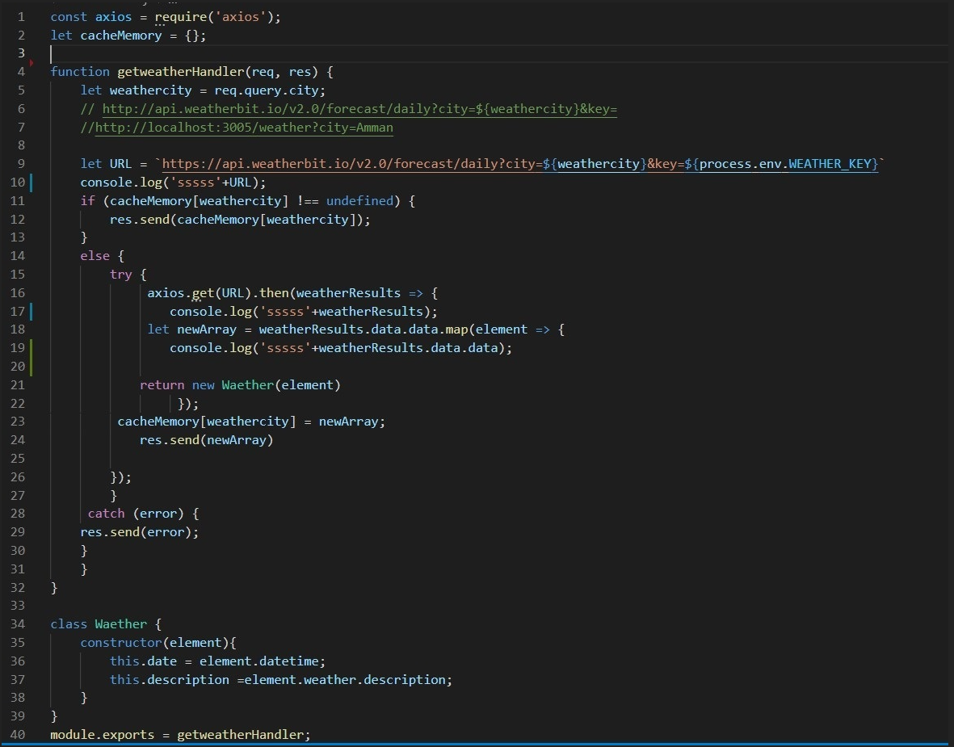

1. I use this method to see if the my api server is working or not

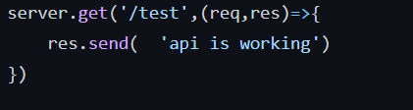

Then I test by wrting consel.log for my requst if I have the data of weather by consel.log

|  |
| --- |
| let URL = `https://api.weatherbit.io/v2.0/forecast/daily?city=${weathercity}&key=${process.env.WEATHER_KEY}`  console.log(URL); |
|  |  |

And here is the data

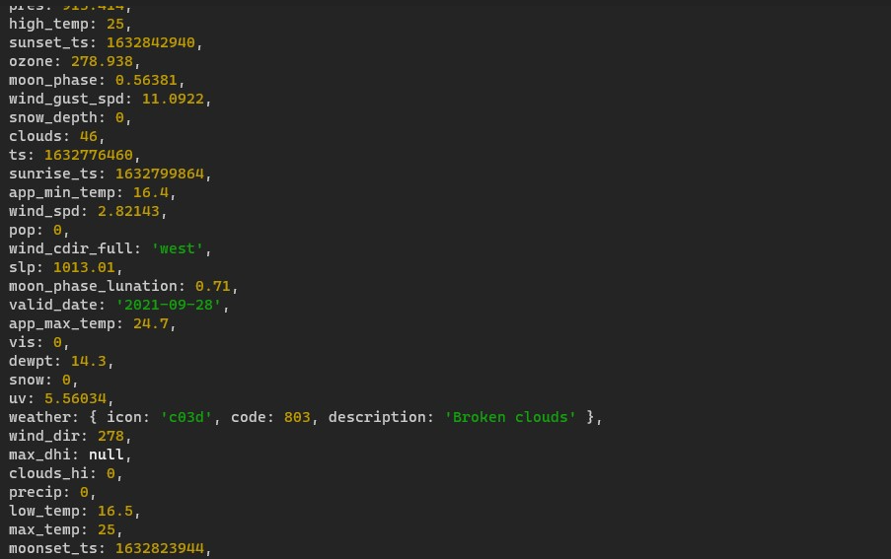

Here I test if I have any error in the function by use try and catch

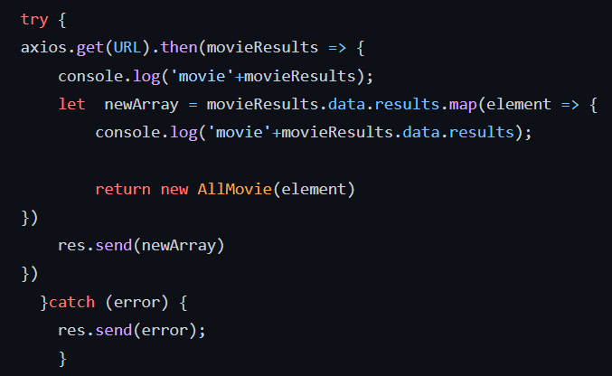

Then I test the broweser if I have the data in backend by test and open the localhost

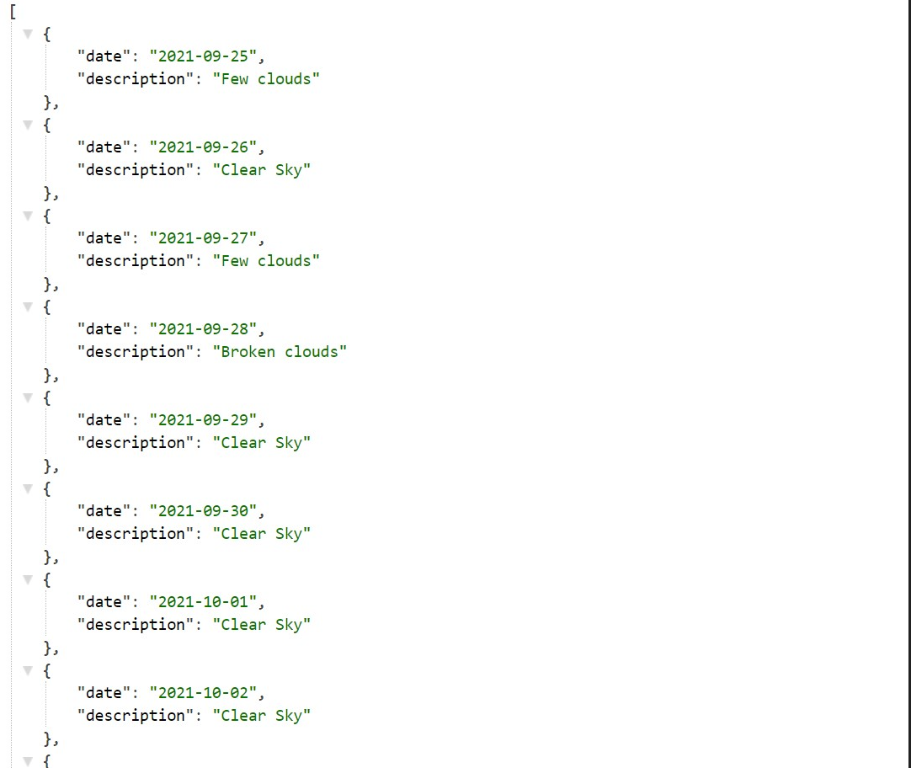

**movie library**

1. I test the code and see if I have any error in the code and as you can see here there is no errors 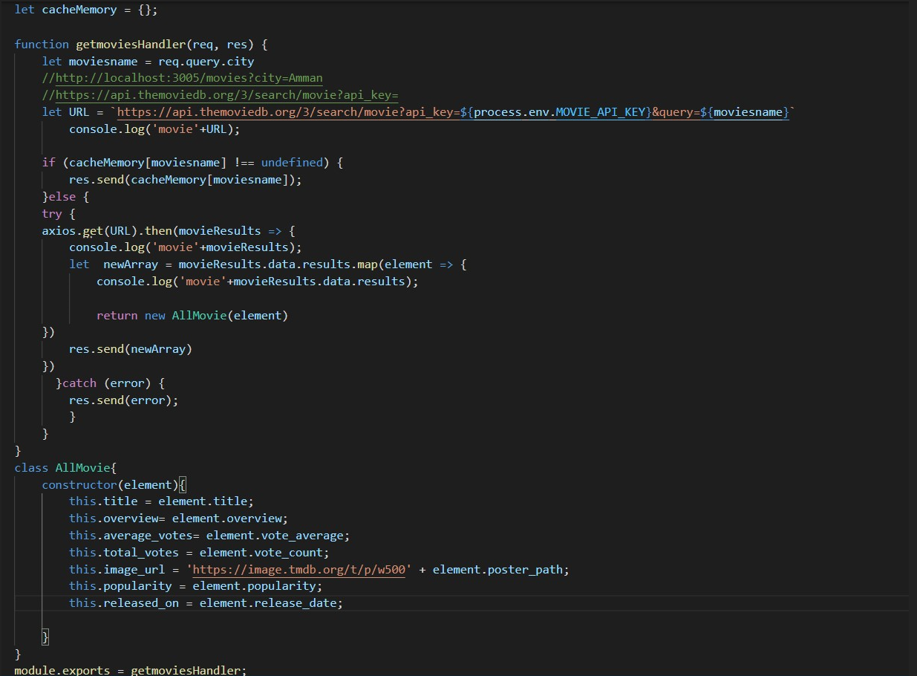
2. I use this method to see if the my api server is working or not



Then I test the broweser if I have the data in backend by test and open the localhost

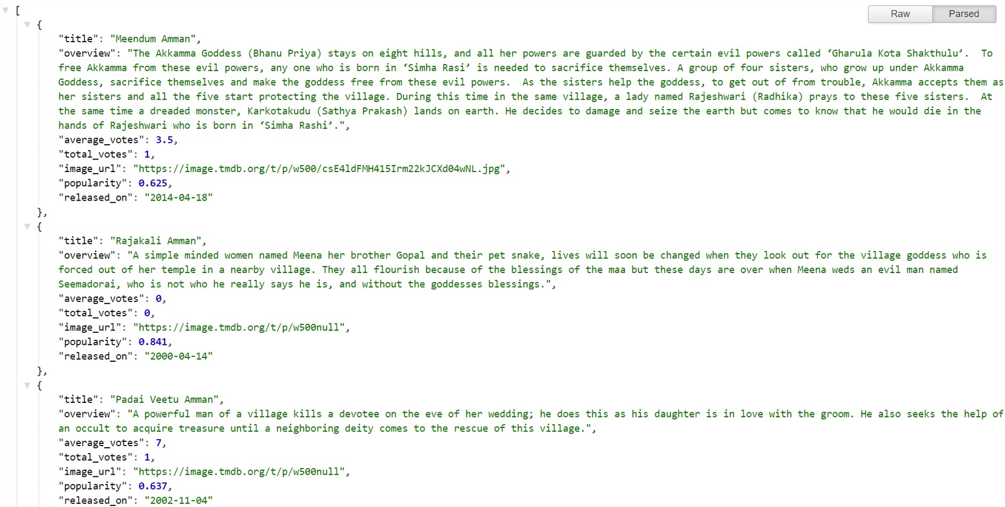

**black box:**

1. here I test the weather if all the weather info are working on user screen.

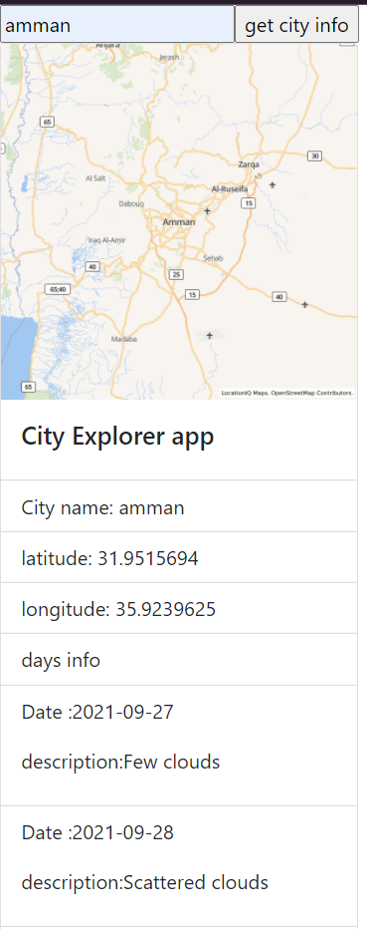

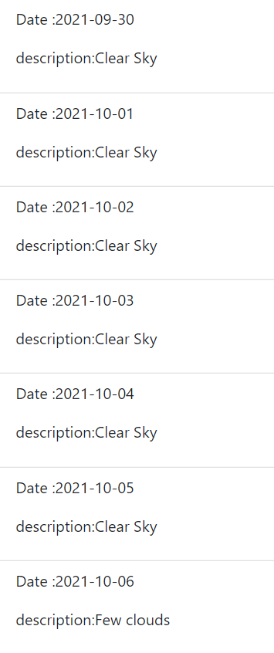

1. here I test the movie if all the movie info are working on user screen.

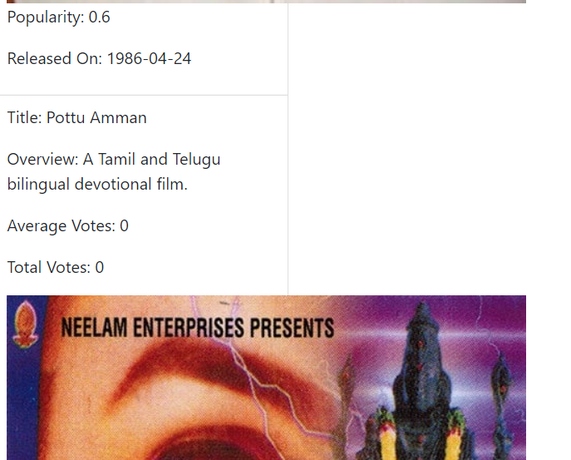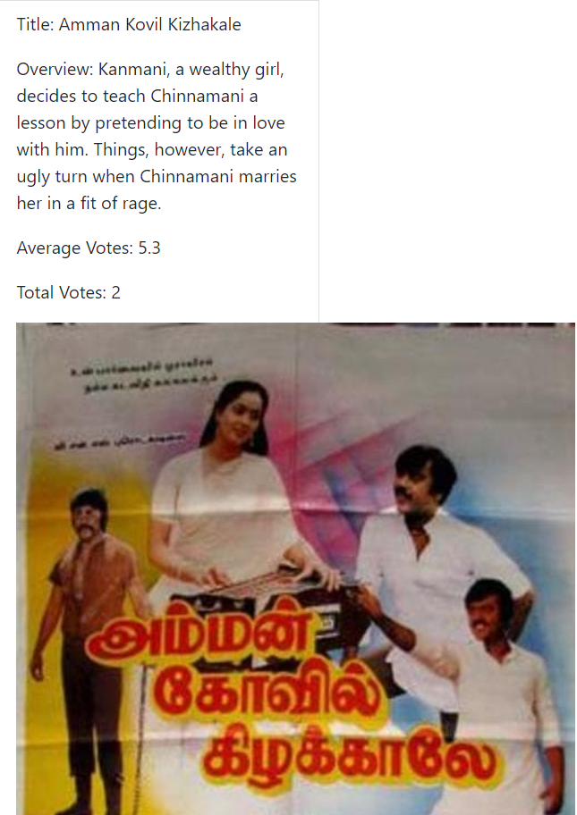

|  |  |  |  |
| --- | --- | --- | --- |
| **Learning Outcomes and Assessment Criteria:** | | | |
| **Learning Outcome number and Title** | **Pass** | **Merit** | **Distinction** |
| **LO1** LO1 Examine what an API is, the need for APIs and types of APIs | **P1** Examine the relationship between an API and a software development kit (SDK). | **M1** Asses a range of APIs for a particular platform that covers a range of uses. | **D1** Evaluate potential security issues surrounding API |
| **LO2** Apply the knowledge of API research to design an application that incorporates relevant APIs for a given scenario or a substantial student chosen application | **P2** Analyse an existing application that could be extended with a suitable API. | **M2** Design an application that will utilise an API for a given purpose. | **D2** Create a design for a chosen substantial application that will utilise a range of APIs, justifying choices. |
| **LO3** Implement an application in a suitable development environment | **P3** Build on an existing application framework to implement an API. | **M3** Develop an application that utilises an API. | **D3** Construct an application utilising multiple APIs, following the designs in LO2. |
| **LO4** Document the testing of the application, review and reflect on the APIs used | **P4** Design and complete a ‘white box’ test of the application, recording the results | **M4** Conduct ‘black box’ tests of your application, recording the results.  **M5** Update the application accordingly with the results. | **D4** Critically evaluate the APIs used within your application. Provide a data security report of your application. |

**Plagiarism**

Plagiarism is a particular form of cheating. Plagiarism must be avoided at all kinds and students who break the rules, however innocently, may be penalised. It is your responsibility to ensure that you understand correct referencing practices. As a student in a university college level, you are expected to use appropriate references throughout and keep carefully detailed notes of all your sources of materials for material you have used in your work, including any material downloaded from the Internet. Please consult the relevant unit teacher if you need any further advice.

**Student Declaration**

|  |  |  |  |
| --- | --- | --- | --- |
| **Date Received 1st submission** |  | **Date Received 2nd submission** |  |
| **Student declaration**  I certify that the assignment submission is entirely my own work and I fully understand the consequences of plagiarism. I understand that making a false declaration is a form of malpractice.  **Student signature: Date:** | | | |

|  |  |  |  |
| --- | --- | --- | --- |
| **Assessor Feedback:** | | | |
|  | | | |
| **Grade:** | **Assessor Signature:** | | **Date:** |
| **Resubmission Feedback:** | | | |
| **Grade:** | **Assessor Signature:** | | **Date:** |
| **Internal Verifier’s Comments:** | | | |
| **Signature** | | **Date:** | |

* Please note that grade decisions are provisional. They are only confirmed once internal and external moderation has taken place and grades decisions have been agreed at the assessment board.

Pearson Education 2016

Higher Education Qualifications

Internal Verification of Assignment Brief